**Employee Learning Platform**

Major Project

Contents

1 Project Overview 2

1.1.1 Brief introduction of the project. 2

1.1.2 Purpose of the project. 2

1.1.3 Goals of the project: 2

2 Project Scope 2

2.1.1 Key features and functionalities . 2

3 Architecture and Technology Stack 2

3.1.1 Overall architecture 2

3.1.2 Architecture 3

3.1.3 Technology stack (e.g., programming languages, frameworks, libraries). 3

4 Web App Components 4

4.1.1 Main components of the app. 4

4.1.1 Purpose of each component. 4

5 User Interface Design 5

5.1.1 User interface (UI) 5

6 Work with Data…………………………………………………………………………………………………….8

6.1.1 Approach for the Data Engineering. 8

6.1.2 Approach for the Machine Learning. 8

# Project Overview

### Brief introduction of the project.

The project aims to develop a user-friendly learning platform for employees facilitating event registrations and access to training resources. It is a platform where employees can log in, administrators can create events, employees can easily register for events they're interested in, with email notifications, and also keeps track of event registrations for capacity management.

### Purpose of the project.

The purpose of our project is to address the need for a centralized platform dedicated to employee learning and development within the organization.

The key goals of the project include:

* Providing employees with easy access to a wide range of learning opportunities. By centralizing these resources on a single platform, we aim to eliminate barriers to learning and ensure that all employees can easily access the information they need to enhance their skills and knowledge.
* Automated email notifications guarantee timely communication with employees regarding new events, registration confirmations, and any updates, encouraging heightened engagement and participation.

### Goals of the project:

* Develop a learning platform that is intuitive and easy to navigate for both administrators and employees, ensuring a seamless user experience.
* Implement a predictive recommendation system in the data engineering aspect, suggesting the next training event based on individual employee skills.

# Project Scope

### Key features and functionalities of the web app.

**Responsive Interface Design:**

Responsive user interface for optimal viewing and usability across different screen sizes

**Personalized Dashboard**:

Customized interface optimized for efficient event management, user administration, and updates, improving administrative effectiveness.

Personalized portal showcasing registered events and real-time updates, simplifying access to learning opportunities and enhancing employee engagement.

**Automated Email Alerts:**

Automated email notifications keep users informed about important updates, such as event creations, registrations, and cancellations, ensuring timely communication and enhancing user engagement.

**Predicting Training Event Based on Employee Skills:**

By analysing historical data and employee profiles, suggesting relevant events tailored to individual skill sets, optimizing learning opportunities and fostering professional development.

# Architecture and Technology Stack

### Overall architecture of the web application.

**Client Side Interface:**

* User Registration and Authentication module facilitates secure creation of employee accounts, featuring username/password authentication.
* Admin Dashboard offers personalized tools for event management, including updating event details and handling user registrations, with intuitive CRUD functionalities.
* Employee Dashboard provides customized views for each employee, showcasing registered events, upcoming events,..

**Backend Services:**

* Authentication Service: Responsible for verifying admin and employee credentials.
* User Management Service: Manages users, implementing role-based access control.
* Event Management Service: Handles training events, including creation, updates, deletion, and registration and capacity management.
* Email notification Service: Sends instant notifications to users concerning event registrations, updates, and more.

**Data Engineering:**

* Data Extraction: Involves retrieving data from database (MongoDB).
* Data Ingestion: Transferring extracted data into a storage system (Snowflake).
* Data Preparation: Includes cleaning, transforming, and structuring the ingested data to ensure consistency.
* Reporting Tables: Generates reporting tables to support operational reporting and analytics, providing insights like user engagement, capacity utilization, etc.

**Data Science:**

* Exploratory Data Analysis: Involves analysing and visualizing the data to understand its characteristics, distributions, and relationships.
* Feature Engineering: Extracts relevant features from the data to feed into the model.
* Model Training: Involves selecting appropriate machine learning algorithms and train them using relevant features.
* Model Prediction: Applying trained models to predict the next training event based on extracted features, facilitating proactive planning and decision-making.

### Architecture

### Technology stack (e.g., programming languages, frameworks, libraries).

**Technology Stack for the Web Application Platform:**

The technology stack for the Mobile Application Platform for employee learning platform will include the following components:

**React JS**:

React JS is an open-source JavaScript library for building user interfaces. It is widely used for creating interactive and dynamic web applications with a focus on component-based architecture.

**React Bootstrap:**

React Bootstrap combines React.js and Bootstrap to provide pre-designed UI components for building responsive web applications. It offers reusable components like buttons, forms, and navigation bars styled with Bootstrap CSS, simplifying development and ensuring consistency across devices.

**Axios:**

Axios is a JavaScript library for making HTTP requests from web browsers or Node.js. It simplifies sending asynchronous requests to RESTful APIs, handling tasks like fetching data and updating resources with ease. It supports features like interceptors and automatic JSON parsing, enhancing its versatility in web development.

**Node.js:**

Node.js is a versatile and powerful platform for building modern web applications, APIs, and micro-services, offering high performance, scalability, and a vibrant ecosystem of tools and libraries. Its combination of JavaScript on both the client and server-side streamlines development and enables full-stack JavaScript development.

**MongoDB:**

MongoDB is a versatile and scalable database solution that is well-suited for a wide range of use cases, including web applications, mobile apps, content management systems, and real-time analytics. Its flexible data model, scalability, and rich feature set make it a popular choice for modern application development.

# Web App Components

### Main components of the mobile app.

* Login
* Forgot Password
* Admin Dashboard
* User Creation
* Event Creation
* User Dashboard
* Calendar

### Purpose of each component.

#### Login

The login function enables access for Admin to the Admin Dashboard, offering options to manage users and events while regular users are redirected to the Employee Dashboard, where they can explore and register for events.

#### Forgot Password

Admin and Employees can regain access to their accounts if they forgot their password.

#### Admin Dashboard

The Admin Dashboard acts as the central hub for administrators to create users, manage events, and update or cancel scheduled events with ease.

#### User Creation

Administrators can create users by providing their name, email, and role. This allows them to define the permissions for each user according to organizational needs.

#### Event Creation

Administrators create events by specifying details such as name, trainer, prerequisites, timing etc., tailored for employee learning and growth.

#### User Dashboard

In the User Dashboard, users can easily navigate to view all available events, as well as those they've already registered for. Additionally, users have the option to register for new events or express interest in upcoming ones.

#### Calendar

In the calendar component, both administrators and users can visualize all events in a calendar view. This feature allows for a comprehensive overview of scheduled events, accessible to both user types.

# User Interface Design

### User interface (UI)

**Login Page:**

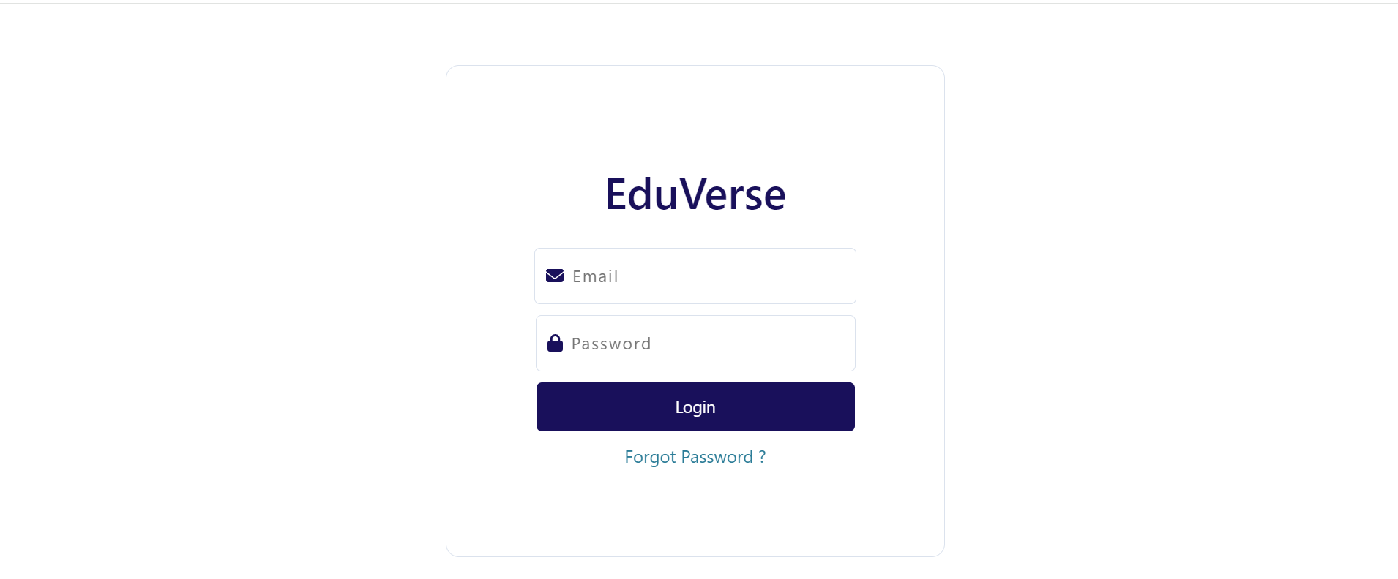

**Forgot Password:**

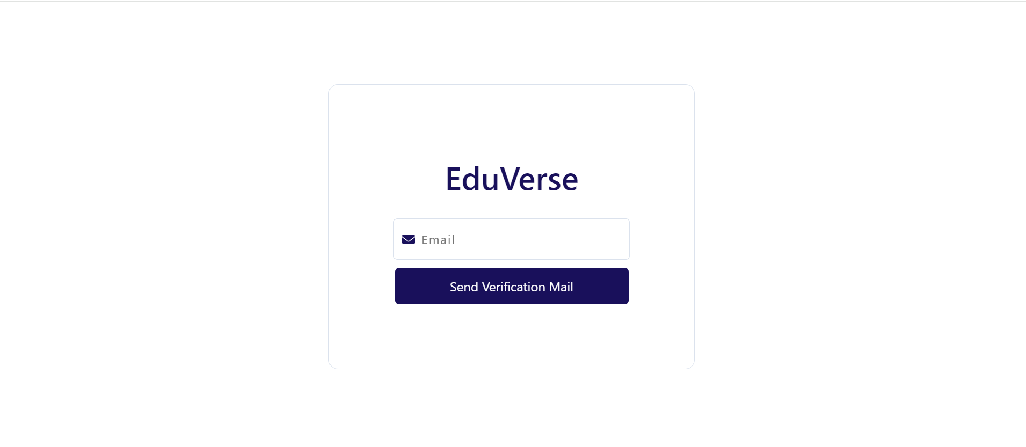

**Reset Password :**

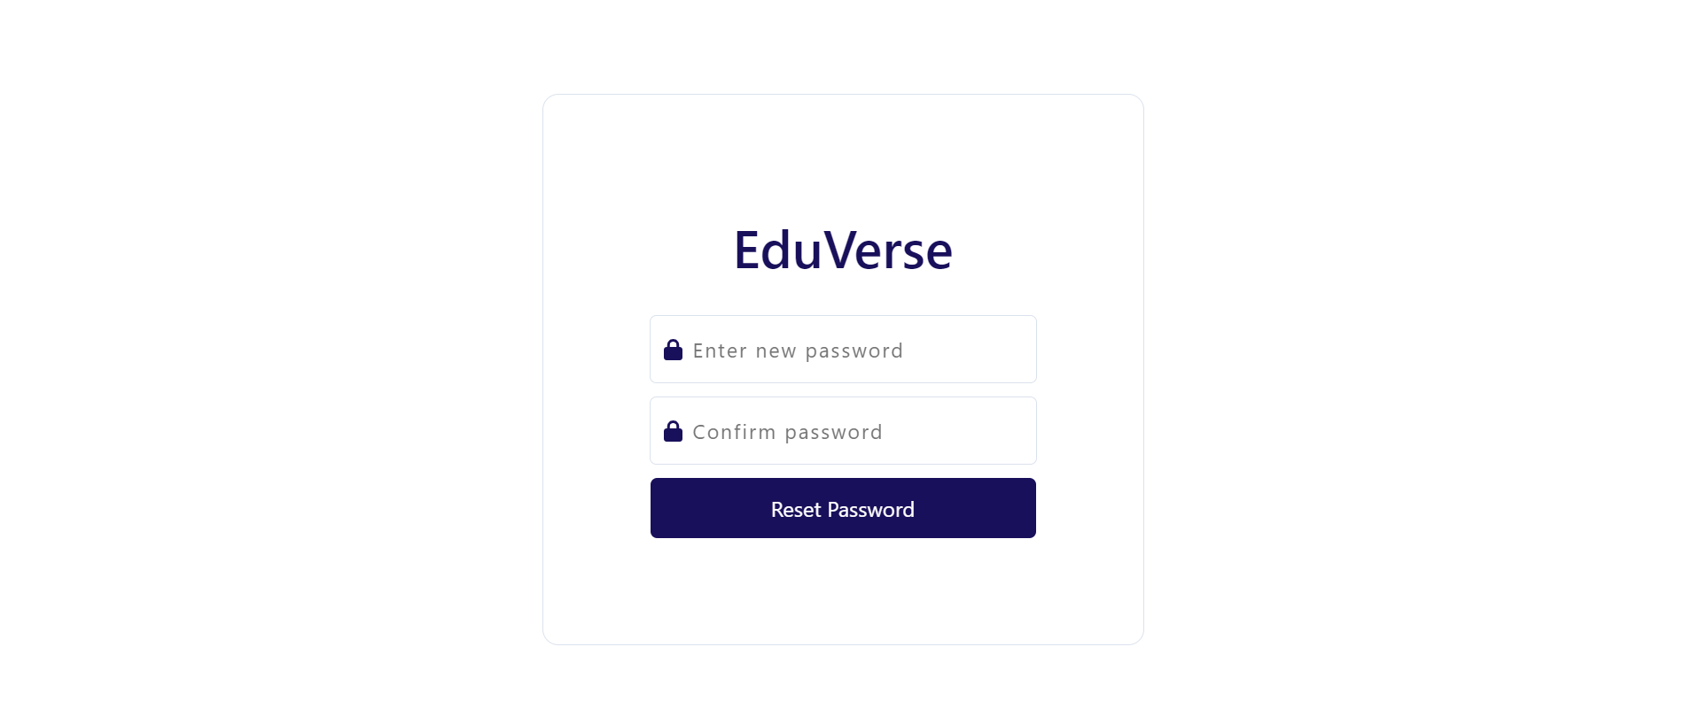

**Admin page:**

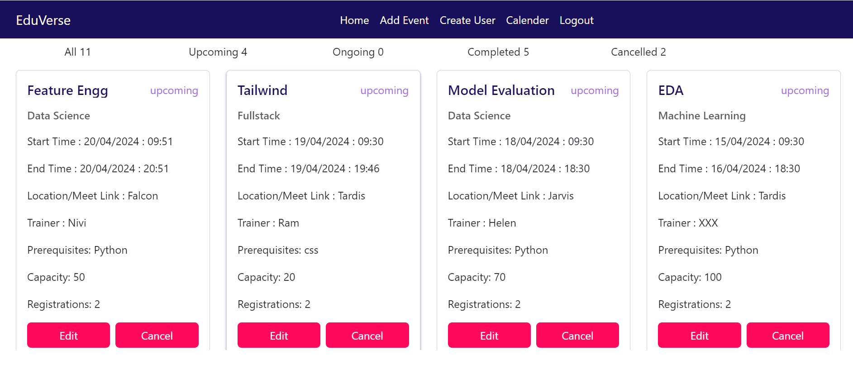

**Event Creation:**

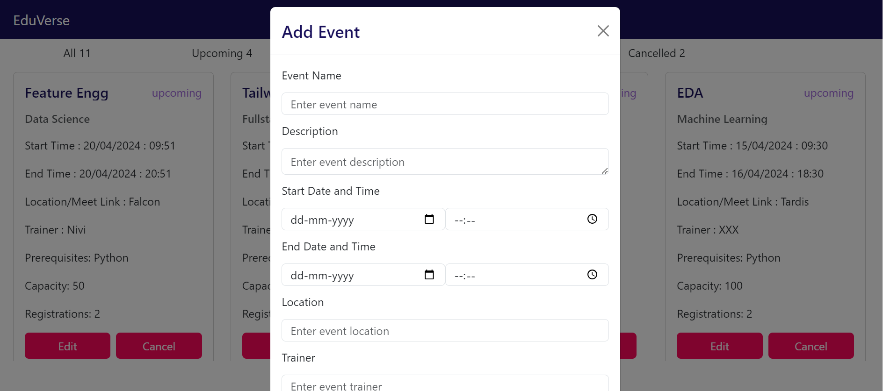

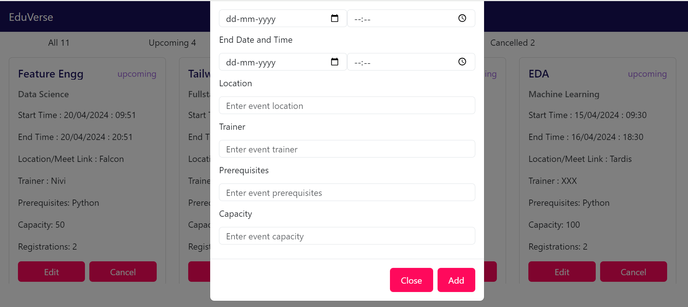

**User Creation**

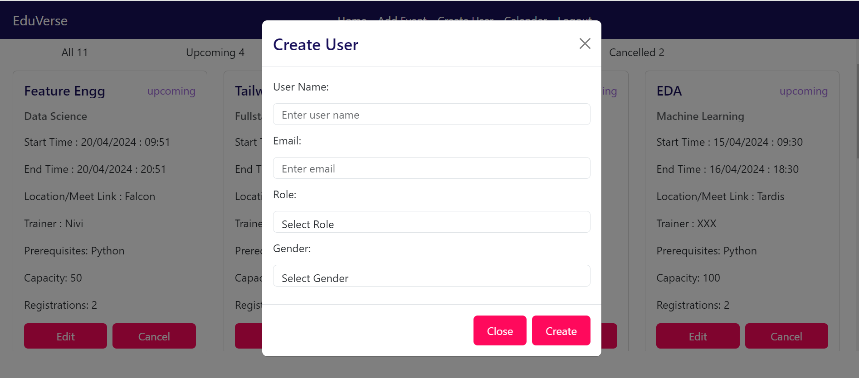

**User page:**

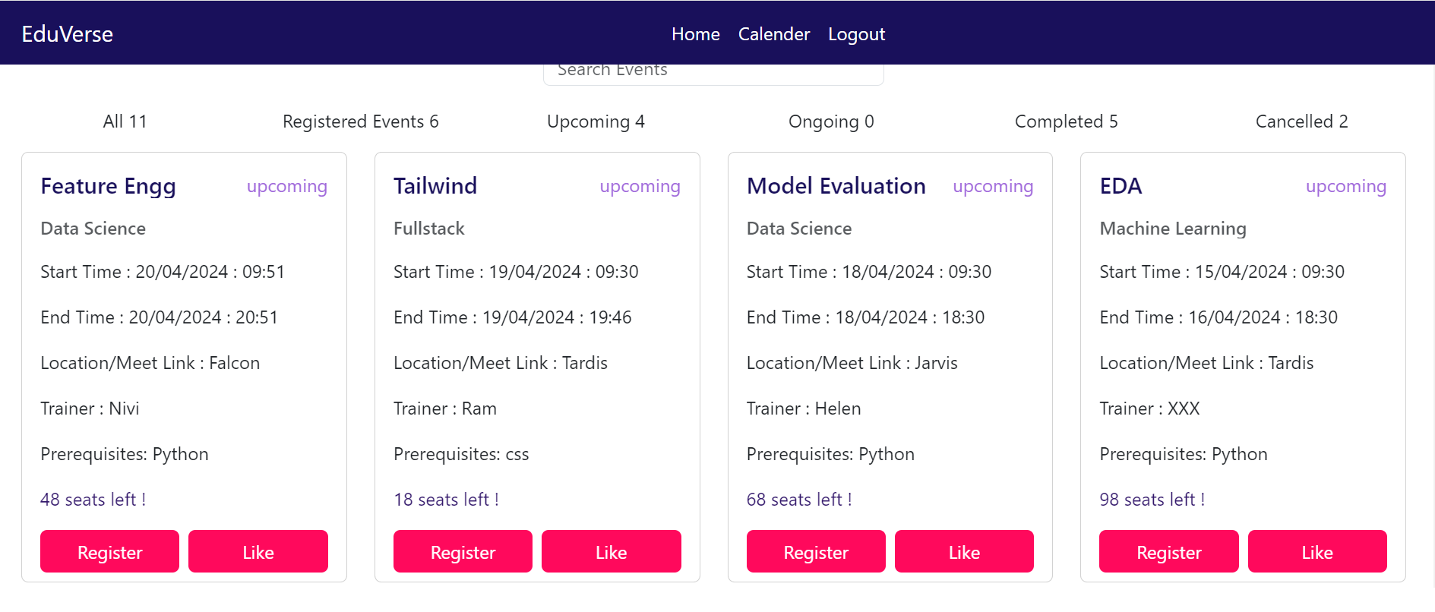

**Calendar:**

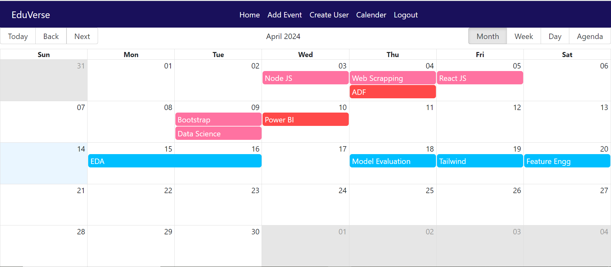

# Work with Data

### Approach for the Data Engineering.

**Snowflake:**

Snowflake serves as a cloud-based data warehouse for storing application data, enabling real-time

analytics, business intelligence, and decision-making.

**DBT:** By integrating dbt into workflow, it is easy to automate and standardize the process of transforming and

preparing reporting tables in Snowflake, enabling efficient and reliable analytics.

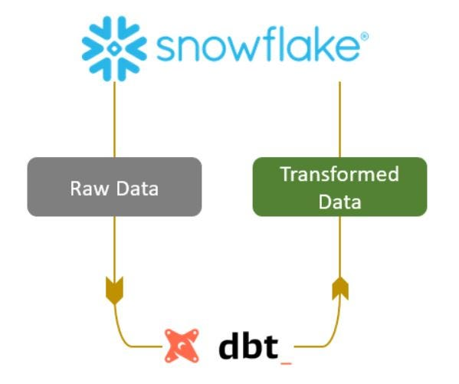

### Approach for the Machine Learning.

**Exploratory Data Analysis (EDA):**

EDA (Exploratory Data Analysis) involves exploring and analyzing data to understand its structure,

patterns, and relationships using statistical and visualization techniques.

**Feature Extraction:**

Feature extraction involves transforming raw data into meaningful features for machine learning models.

It aims to reduce dimensionality while preserving relevant information, enhancing model performance

and interpretability.

**Model Development:**

In predicting the next event, we start by selecting a suitable machine learning model. Training the model

on historical data follows, learning patterns and relationships. Testing its performance on unseen data is

crucial for evaluating its generalization ability. Once trained, the model predicts the next event based on

extracted features.

**Appendix Title**

Document Title